Karnataka Law Society’s
GOGTE INSTITUTE OF TECHNOLOGY
Department of Computer Science and Engineering
Udyambag Belagavi -590008
Karnataka, India.



A Lab Course activity project on
Interface Ultrasonic sensor with Arduino uno to detect obstacle and display appropriate Alert message on LCD
Submitted for the requirements of 6th semester B.E. in CSE
for “EMBEDDED SYSTEM AND INTERNET OF THINGS”
Submitted by
NAME | USN
Umesh Bhati | 2GI19CS168
Viraj Talathi | 2GI19CS181
Tanay Gargate | 2GI19CS162
Sushant Patil | 2GI19CS160

Under the guidance of
Ms. Sharada Kori
Asst. Prof., Dept. of CSE
Academic Year 2021-2022 (Odd semester)

Karnatak Law Society’s
GOGTE INSTITUTE OF TECHNOLOGY
Udyambag Belagavi -590008
Karnataka, India.
Department of Computer Science and Engineering

Certificate
This is to certify that the Course Activity titled “Interface Ultrasonic sensor with Arduino uno to detect obstacle and display appropriate Alert message on LCD” carried out byUmesh Bhati, Viraj,Tanay,Sushant bearing USNs: 2GI19CS168, 2GI19CS181, 2GI19CS162, 2GI19CS160 is submitted in partial fulfillment of the requirements for 6th semester B.E. in Computer Science and Engineering, Visvesvaraya Technological University, Belagavi. It is certified that all corrections/ suggestions indicated have been incorporated in the report. The course project report has been approved as it satisfies the academic requirements prescribed for the said degree.

Place: Belagavi Signature of Guide
KLS Gogte Institute of Technology, Belagavi. Prof. Sharada Kori
Asst. Professor

Marks allocation
 | Batch No. :9
1. | Seminar/Project Title:  Interface Ultrasonic sensor with Arduino uno to detect obstacle and display appropriate Alert message on LCD | Marks Range
2. | Abstract (PO2) | 0-2
3. | Application of the topic to the course (PO2) | 0-3
4. | Literature survey and its findings (PO2) | 0-4
5. | Methodology, Results and Conclusion (PO1,PO3,PO4) | 0-6
6. | Report and Oral presentation skill (PO9,PO10) | 0-5
 | Total | 20
* 20 marks is converted to 10 marks for CGPA calculation
1.Engineering Knowledge: Apply the knowledge of mathematics, science, engineering fundamentals and an engineering specialization to the solution of complex engineering problems.
2.Problem Analysis: Identify, formulate, review research literature, and analyze complex engineering problems reaching substantiated conclusions using first principles of mathematics, natural sciences and Engineering sciences.
3.Design/Development of solutions: Design solutions for complex engineering problems and design system components or processes that meet the specified needs with appropriate consideration for the public health and safety, and the cultural, societal, and environmental considerations.
4.Conduct investigations of complex problems: Use research-based knowledge and research methods including design of experiments, analysis and interpretation of data, and synthesis of the information to provide valid conclusions.
5.Modern tool usage: Create, select, and apply appropriate techniques, resources, and modern engineering and IT tools including prediction and modeling to complex engineering activities with an understanding of the limitations.
6.The engineer and society: Apply reasoning informed by the contextual knowledge to assess societal, health, safety, legal and cultural issues and the consequent responsibilities relevant to the professional engineering practice.
7.Environment and sustainability: Understand the impact of the professional engineering solutions in societal and environmental contexts, and demonstrate the knowledge of, and need
for sustainable development.
8.Ethics: Apply ethical principles and commit to professional ethics and responsibilities and norms of the engineering practice.
9.Individual and team work: Function effectively as an individual and as a member or leader in diverse teams, and in multidisciplinary settings.
10.Communication: Communicate effectively on complex engineering activities with the engineering community and with society at large, such as, being able to comprehend and write effective reports and design documentation, make effective presentations, and give and receive clear instructions.
11. Project management and finance: Demonstrate knowledge and understanding of the engineering management principles and apply these to one's own work, as a member and leader in a team, to manage projects and in multidisciplinary environments.
12. Life-long learning: Recognize the need for and have the preparation and ability to engage in independent and lifelong learning in the broadest context of technological channel

CONTENT
- Title
- Problem Definition
- Components used
- Design/Functional Block Diagram
- Manual Calculation if any
- Working Model of the final solution
- Working code for mini project
- Conclusion
- References

TITLE : ULTRASONIC SENSOR

PROBLEM STATEMENT :

Interface Ultrasonic sensor with Arduino uno to detect obstacle and display appropriate Alert message on LCD

COMPONENTS USED :

- 1 × Breadboard
- 1 × Arduino Uno R3
- 1 × ULTRASONIC Sensor (HC-SR04)
- 1 x JUMPER WIRES

BLOCK DIAGRAM:
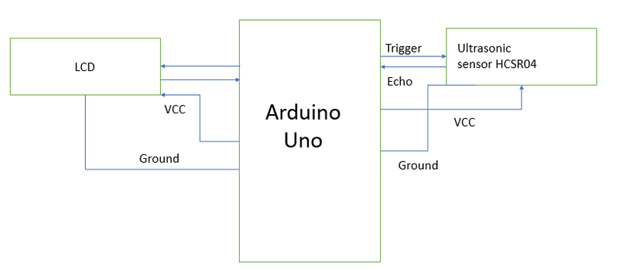

WORKING OF FINAL MODEL

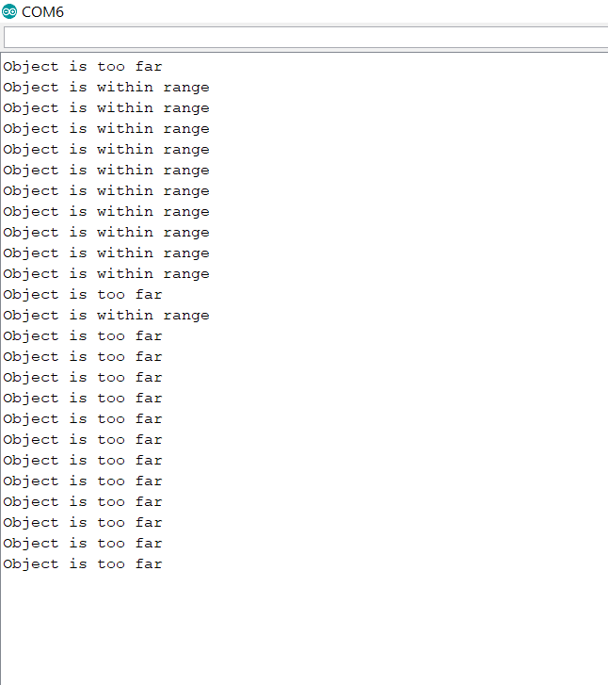

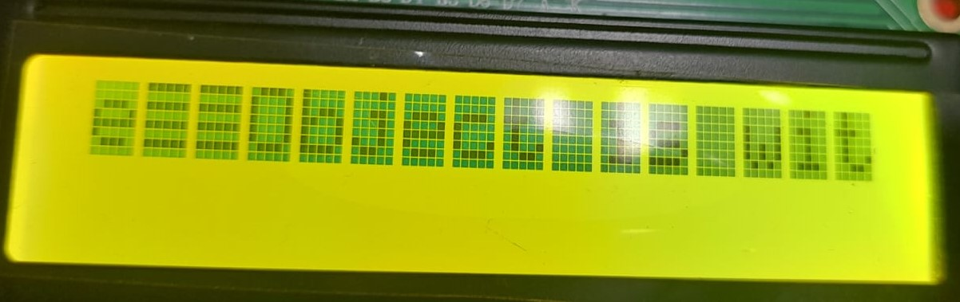

CODE :

const int trigPin = 6; //trig Arduino pin 21/D7 or Board pi 37
const int echoPin = 7; //Echo Arduino pin 20/D6 or Board pi 35
// defines variables
long duration;
int distance;

void setup() {
pinMode(trigPin, OUTPUT); // Sets the trigPin as an Output
pinMode(echoPin, INPUT); // Sets the echoPin as an Input
Serial.begin(9600); // Starts the serial communication
}

void loop() {
// Clears the trigPin
digitalWrite(trigPin, LOW);
delayMicroseconds(2);
// Sets the trigPin on HIGH state for 10 micro seconds
digitalWrite(trigPin, HIGH);
delayMicroseconds(10);
digitalWrite(trigPin, LOW);
// Reads the echoPin, returns the sound wave travel time in microseconds
duration = pulseIn(echoPin, HIGH);
// Calculating the distance
distance= duration*0.034/2;
// Prints the distance on the Serial Monitor
Serial.print("Distance: ");
Serial.println(distance);
delay(2000);
}

CONCLUSION :

From this experiment we are able to understand how the ultrasonic works in aurdino uno and how to interface it with lcd.

REFERENCES :

https://create.arduino.cc/projecthub/abdularbi17/ultrasonic-sensor-hc-sr04-with-arduino-tutorial-327ff6

